**AUTHOR PORTFOLIO**

**MARGARET ATWOOD**

**CREATION**

**Creating Navigation Pages using Content Page**

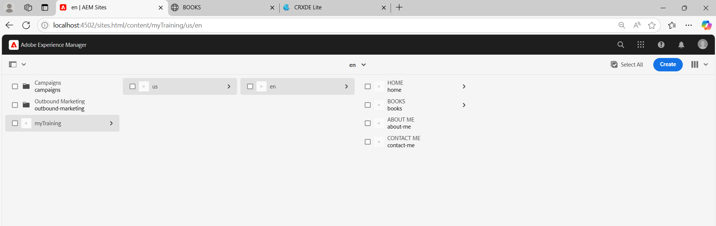

**Creating Template and enabling it**

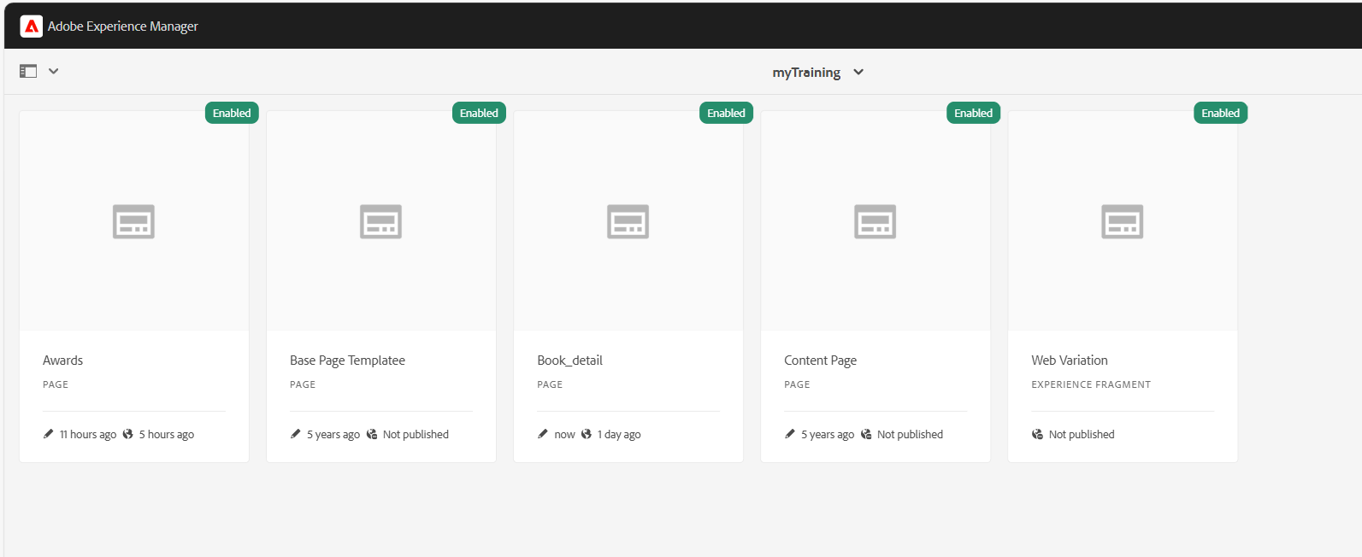

**Using the Template, creating pages for awards**

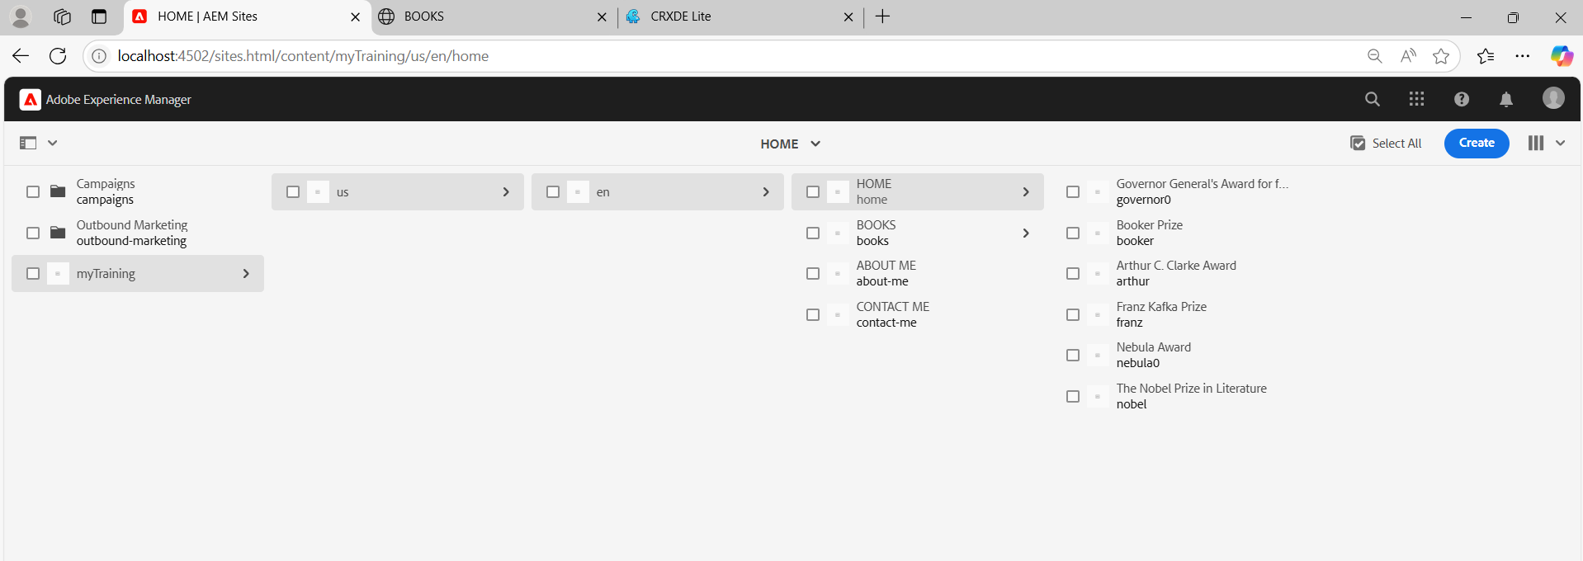

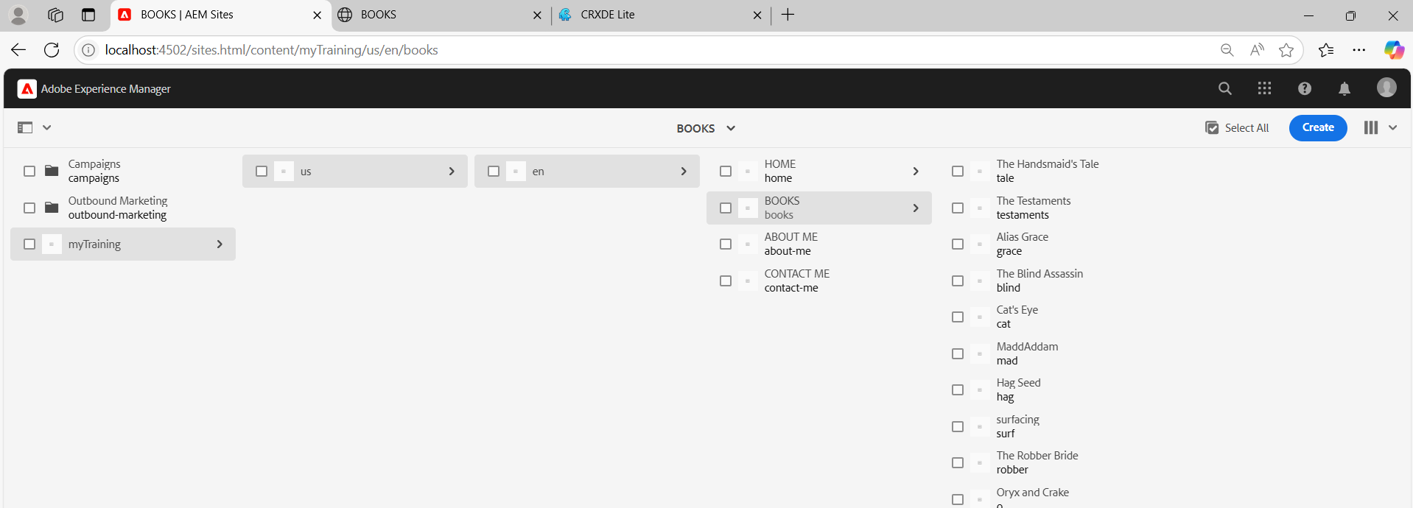

**Styling the header using Embed component and ui.frontend**

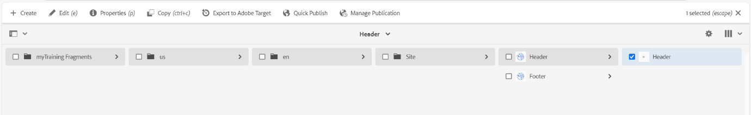

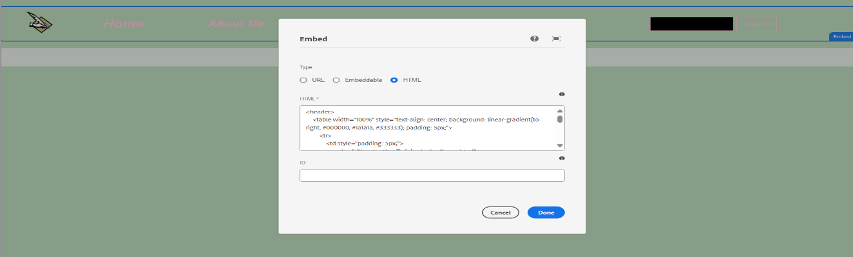

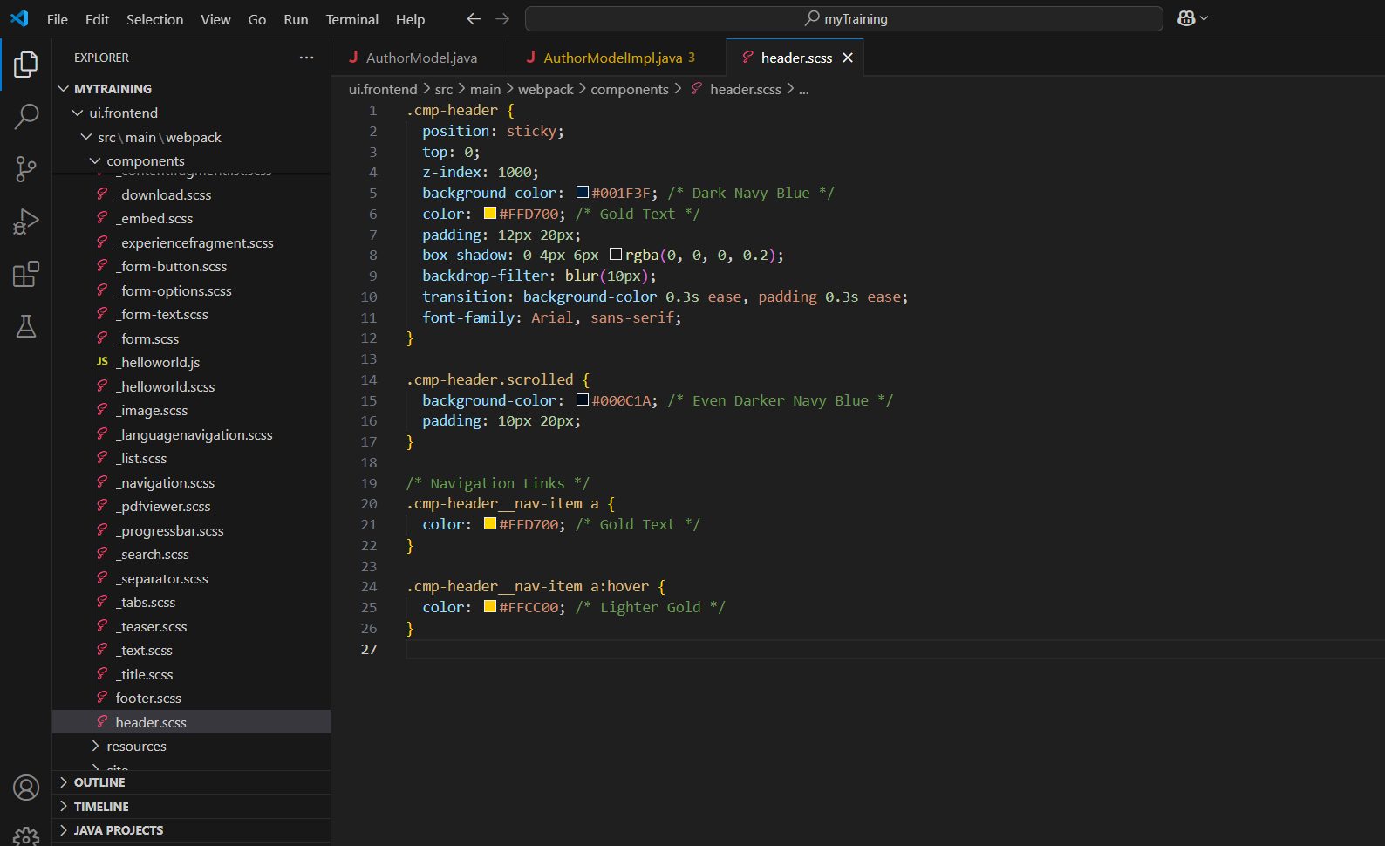

**Styling Footer using Embed component** **and ui.frontend**

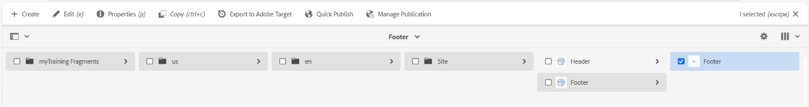

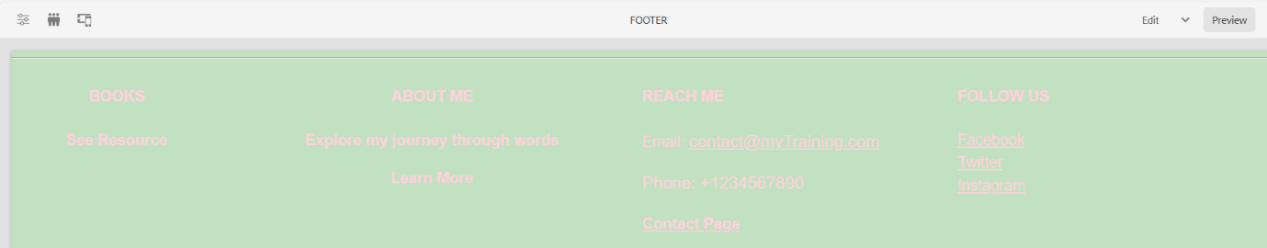

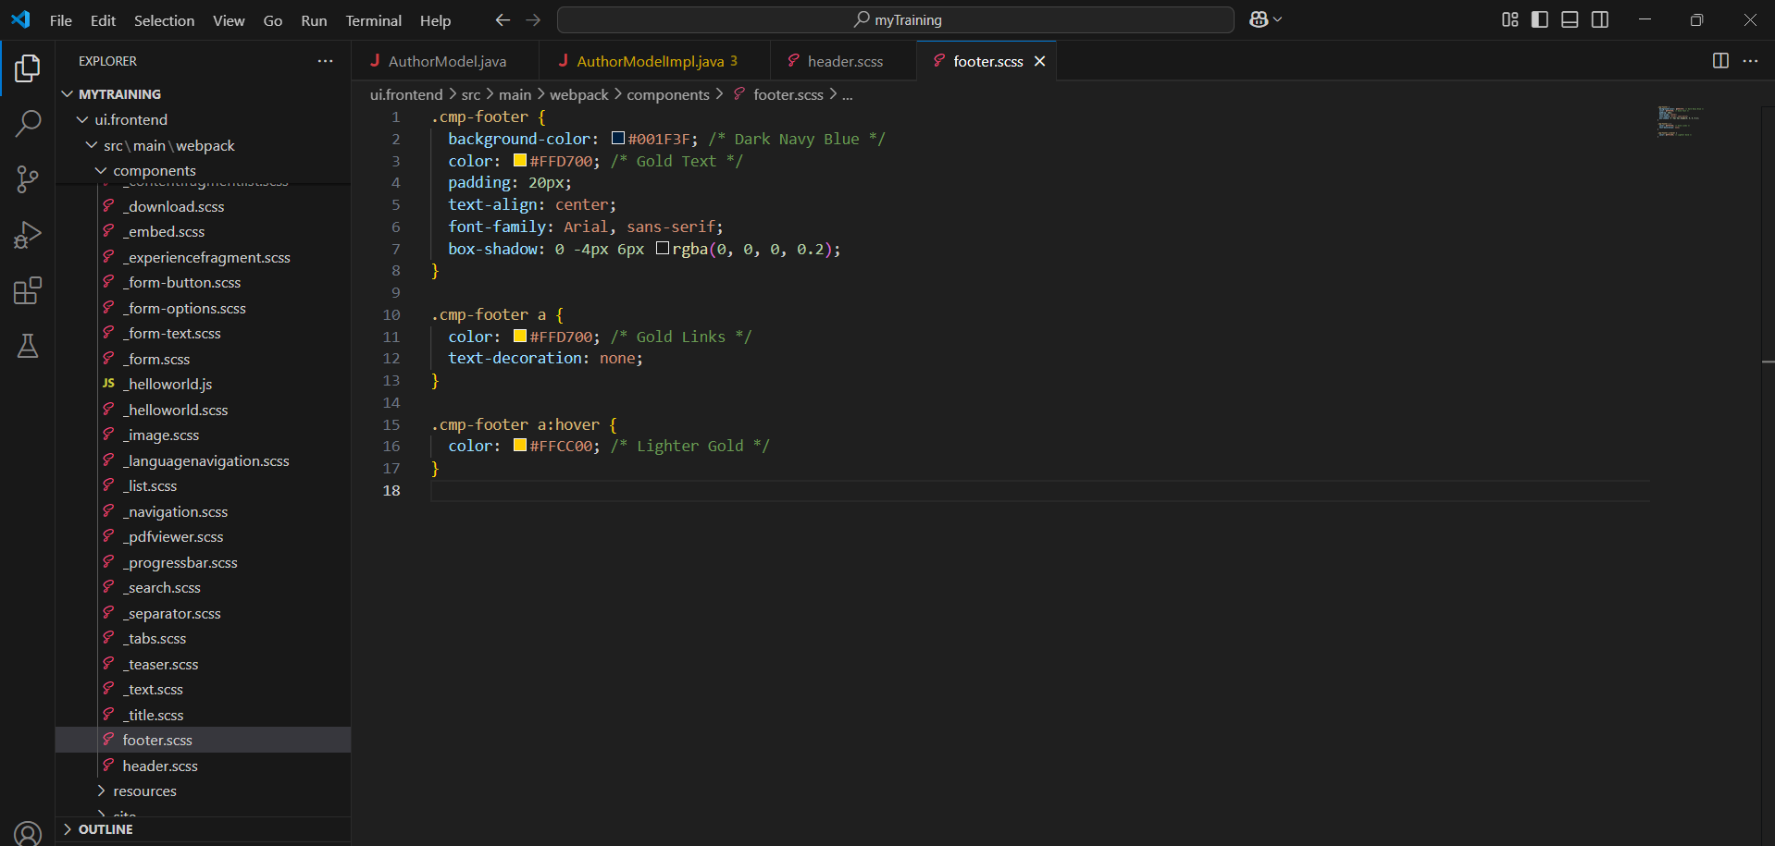

**Author Component**

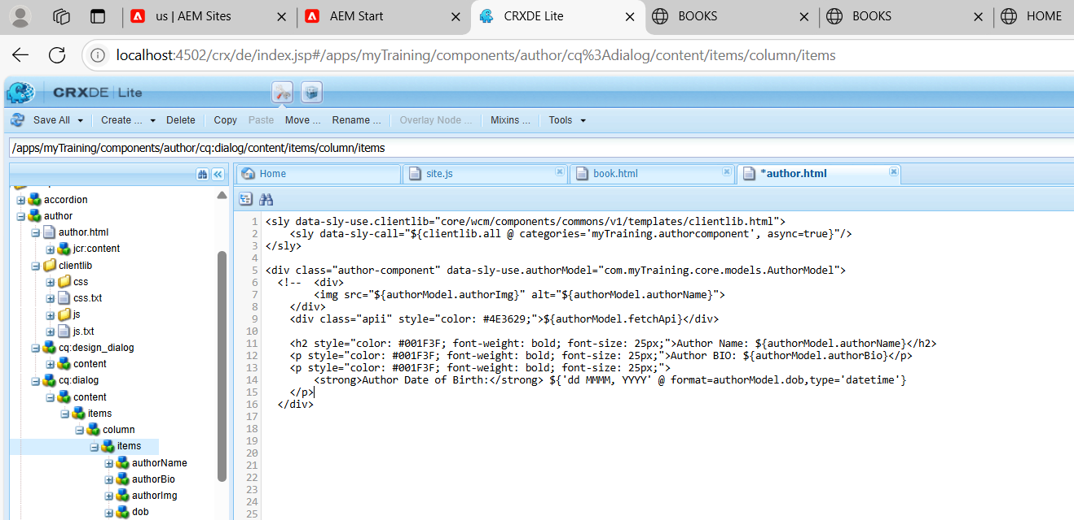

**AuthorModelImplementation**

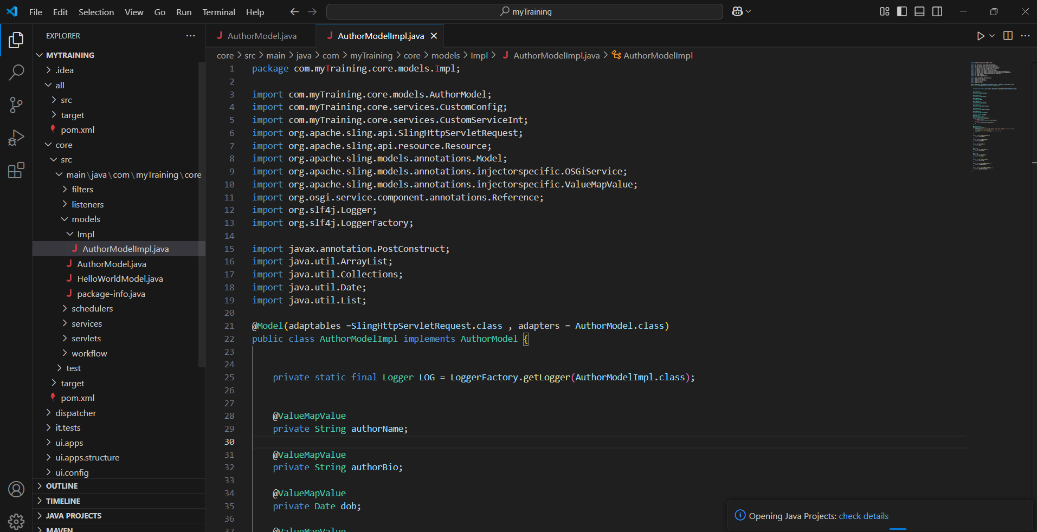

**Book Page Component**

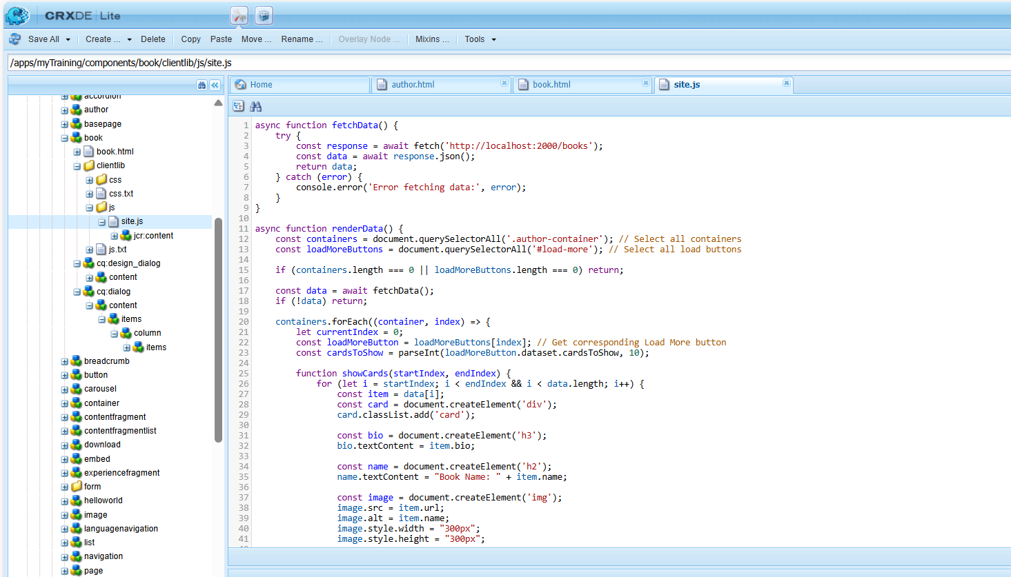

**BookModelImplementation**

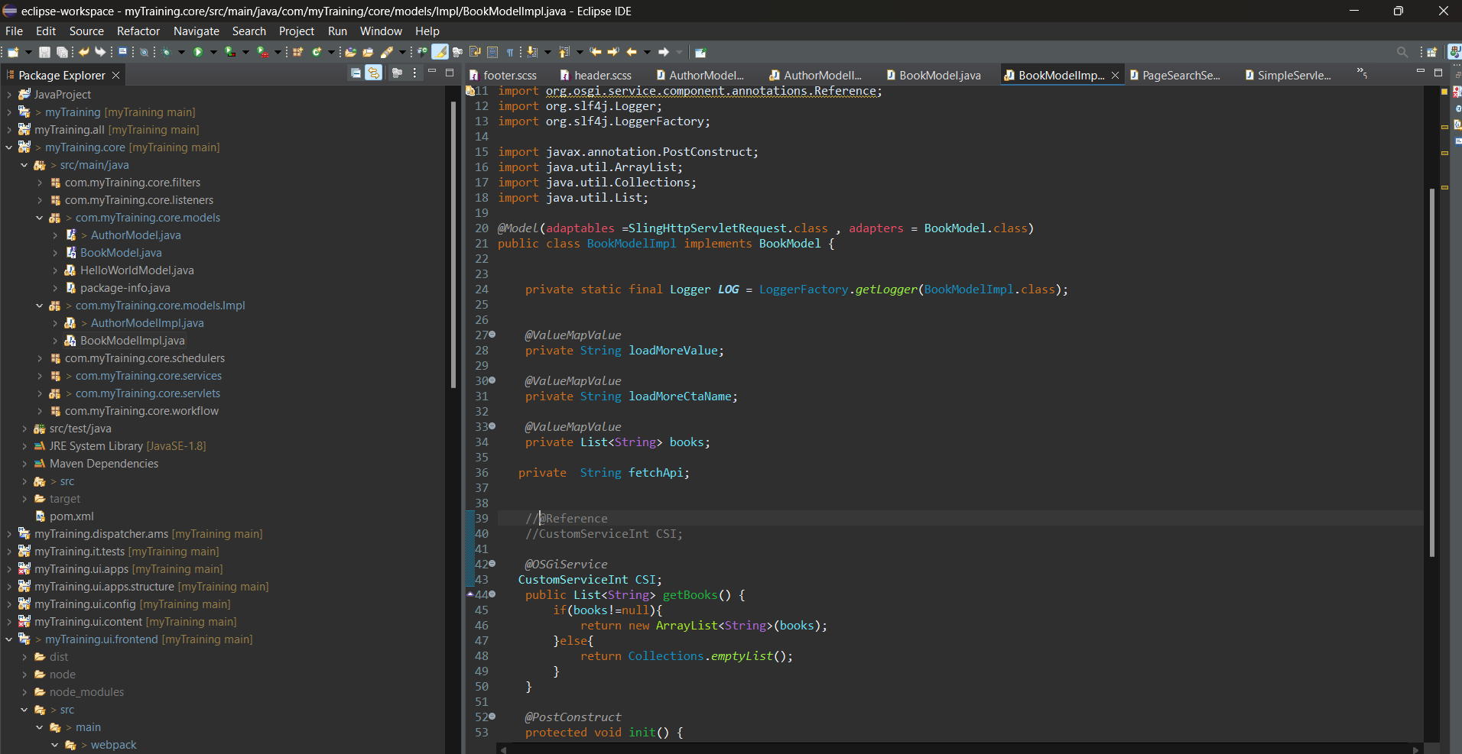

**JSON file (Third party API) for books**

